Test results

# **Pytesseract**

Easy to use, great accuracy for paragraphs

## Input:-

Output:-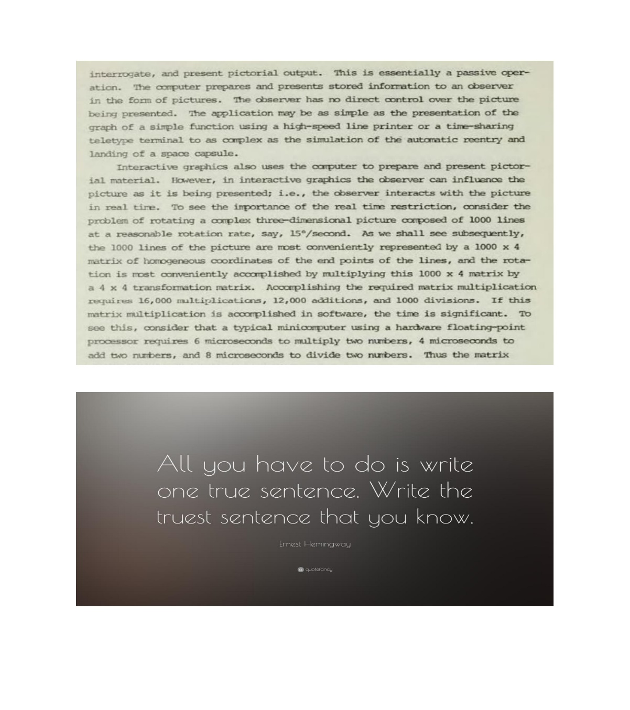

interrogate, and present pictorial output. This is essentially a passive oper-

ation. �The computer prepares and presents stored information to an observer

in the form of pictures. The observer has no direct control over the picture

being presented. The application may be as simple as the presentation of the

graph of a simple function using a high-speed line printer or a time-sharing

teletype terminal to as complex as the simulation of the automatic reentry and

landing of a space capsule.

Interactive graphics also uses the computer to prepare and present pictor-

ial material. However, in interactive graphics the observer can influence the

picture as it is being presented; i.e., the observer interacts with the picture

in real tire. To see the importance of the real time restriction, consider the

problem of rotating a complex three-dimensional picture composed of 1000 lines

at a reasonable rotation rate, say, 15�/second. As we shall see subsequently,

the 1000 lines of the picture are most conveniently represented by a 1000 x 4

matrix of homogeneous coordinates of the end points of the lines, and the rota-

tion is most conveniently accomplished by multiplying this 1000 x 4 matrix by

a 4 x 4 transformation matrix. Accomplishing the required matrix multiplication

requires 16,000 multiplications, 12,000 additions, and 1000 divisions. If this

matrix multiplication is accomplished in software, the time is significant. To

see this, consider that a typical minicomputer using a hardware floating-point

processor requires 6 microseconds to multiply two numbers, 4 microseconds to

add two numbers, and 8 microseconds to divide two numbers. Thus the matrix

Al you have to do is write

one true sentence. Write the

truest sentence that you know.

Ernest Hemingway

Input:-



Output:-

OOOO HC

een fe tote ete

arene e.e eee

Gft, WMG G

tage

♀

Input:-



Output:-

ple te Self

YOU CAN’T CONTROL HOW OTHER

PEOPLE RECEIVE YOUR ENERGY.

ANYTHING YOU DO OR SAY GETS

FILTERED THROUGH THE LENS OF

WHATEVER PERSONAL SHIT THEY

ARE GOING THROUGH AT THE

MOMENT. WHICH IS NOT ABOUT YOU.

JUST KEEP DOING YOUR THING WITH AS

MUCH INTEGRITY AND LOVE AS POSSIBLE.

POSITIFITY.COM

Input:-

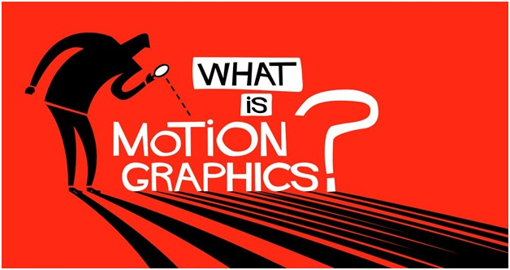

Output:-

No output

Input:-

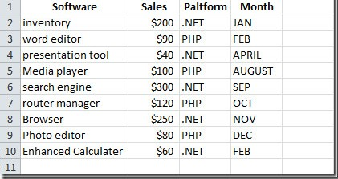

Output:-

CoN anew

10

i

Software

inventory

word editor

presentation tool

Media player

search engine

router manager

Browser

Photo editor

Enhanced Calculater

Sales

$200

$90

$0

$100

$300

$120

$250

$80

$60

Paltform Month

.NET

PHP

.NET

PHP

.NET

PHP

.NET

PHP

NET

JAN

FEB

APRIL

AUGUST

SEP

oct

Nov

DEC

FEB

♀

Input:-



Output:-

80 HURRY

Pros:-

1)great for paragraph reading.

Errors:-

1) botched ink

2) images with so many colors and graphics

3)Extremely blurred images(Low variance)

4)Calligraphy

# **Easyocr**

Overall poor accuracy, great for converting tables and accounting material

Same input

Output:-

Havever, in interactiv grarhics the abserver can influence the picture &s it is beirg presented; i.e. Lhe observer interacts with thc picture 1n real cre 7o see thc iportaroe Of the real tine restriction, consider the problen of rotating & aplex three-dirensioal picture cxposed of 1OCO Lines at a reasonable rotation rate, say , 15e / second . As we shall sce subsequencly , the 1000 Lines of the picture are most conveniently represented by 4 100 * 4 matrix 0f honogeneous cordinales 05 Lhe erd points of Lhe Lires, ard the rota" ion is mst conveniently acoaplished by multiplying this 1OOO x 4 matrix by a ^ * 4 cransfonation mtrix: Accplishing tke required matrix multiplication requires 16,000 muleiplications 4 12,000 acditions , and 1000 divisions . If tis matrix multiplication is acoxplished in softxare, the tine is significant. To see thls , consider tat & typical miniouputer using a hardxare floating point prooessor requires 6 microseconds to multiply

twb nubers, microscoonds Co add 10 nubers , and 8 microseconds to divide two nubers . Tnts Lhe latrix', 'All you have to do is write one true sentence Write the truest sentence that you know Ernest Hemingway', 'quotelancy']

Input:-



Output:-

['"The WGy | see it, ifyou want the rainbow; you gotta taiut up with the II DOLLY PARTON']

Input:-



Output:-

['"Ael as if what you do makes a differenee. [T\' DOES?', 'WILLIAM JAMES', 'GH']

Input:-

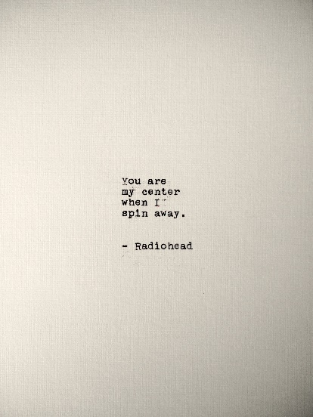

Output:-

['You are my center when I spin away .', 'Radiohead']

Input:-

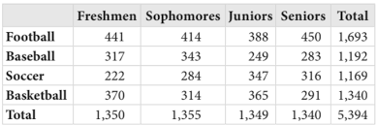

Output:-

['Freshmen Sophomores Juniors Seniors Total Football 441 414 388 450 1,693 Baseball 317 343 249 283 1,192 Soccer 222 284 347 316 1,169 Basketball 370 314 365 291 1,340 Total 1,350 1,355 1,349 1,340 5,394']

Input:-



Output:-

['[e Jind . {vt evetyone ycu mesis Tufena 4 64tle']  
Input:-



Output:-

['Konuray']

pros:-

1)Scans tables perfectly

Errors:-

1)Hybrid color backgrounds (graphic images, images with lots of different colours)

2)Images with crowded text

3)Low variance images

4)calligraphy